Biology Test Number 2

Name ____________________________________________________

|  |  |  |
| --- | --- | --- |
|  | Possible mark | Your mark |
| Multiple choice | 15 |  |
| Short answer | 30 |  |

Please place a **cross** on the answer which you think is most correct.

|  |  |
| --- | --- |
| 1 [A] [B] [C] [D] | 11 [A] [B] [C] [D] |
| 2 [A] [B] [C] [D] | 12 [A] [B] [C] [D] |
| 3 [A] [B] [C] [D] | 13 [A] [B] [C] [D] |
| 4 [A] [B] [C] [D] | 14 [A] [B] [C] [D] |
| 5 [A] [B] [C] [D] | 15 [A] [B] [C] [D] |
|  |  |
| 6 [A] [B] [C] [D] |  |
| 7 [A] [B] [C] [D] |  |
| 8 [A] [B] [C] [D] |  |
| 9 [A] [B] [C] [D] |  |
| 10 [A] [B] [C] [D] |  |

1. 1. Choose the correct term for the following definition: ‘a sudden change in the genes of an organism.’

A natural selection

B evolution

C adaptation

D mutation

1. 2. The number and range of different species that exist on Earth is referred to as:

A geodiversity

B genotype

C biodiversity

D mutation

3. The source of all variation in organisms is:

A mutation

B Natural selection.

C Speciation

D Evolution

Use the diagram below to answer question 5. And 6. 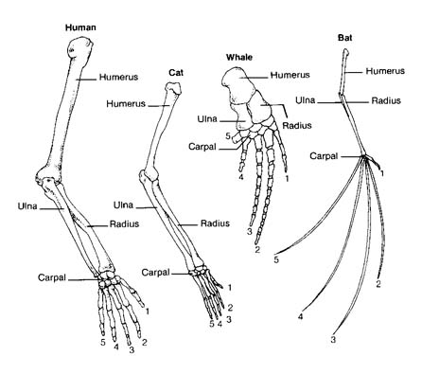

5. These different animals have:

A similar anatomical structures

B the same DNA

C Similar fossils

D mutations

6. The picture of the animals bones in the diagram are used as evidence of:

A Evolution

B Genetics

C Fossils

D Mutations

Use the diagram below to answer question 7 and 8.

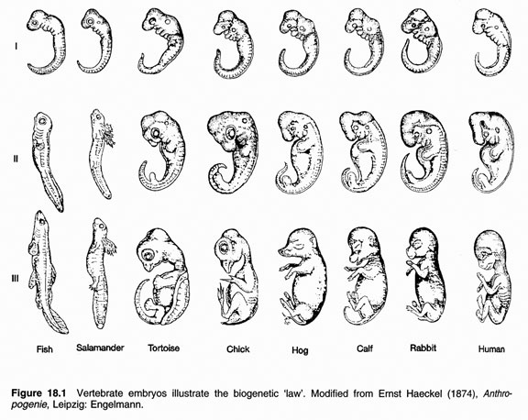

7. The study of these animals in their early developmental stages is called:

A Comparative embryology.

B Comparative anatomy.

C Comparative fossils.

D Mutations

8. From this diagram some people argue that:

A Fish are more closely related to Humans than Chickens.

B Humans are more closely related to rabbits than to fish.

C All rabbits start life as fish.

D Rabbits evolved into fish.

9. The theory of evolution was first put forward by:

A Carl Lineas.

B Albert Einstein.

C Charles Darwin.

D Homo erectus.

10. Members of the same species:

A Look identical to each other.

B Live in the same country.

C Cannot mate with each other.

D Are able to mate and produce fertile offspring with other members of that species.

11. The correct order of events in the process of speciation is:

A isolation, selection and variation.

B Selection, variation and isolation.

C Variation, isolation and selection.

D variation, fossilisation and selection.

Use these diagrams to answer question 12.

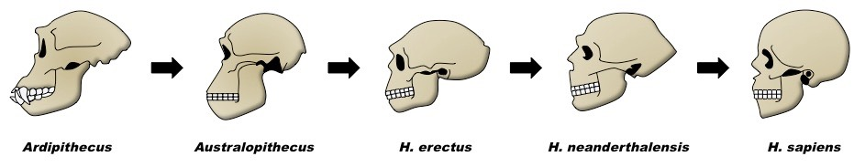

12. This diagram shows that:

A There is a trend in reduced prognation from Australopithecus to Homo sapiens.

B Humans have a smaller cranial capacity compared to Australopithecus.

C Homo erectus has a flatter face than Homo sapiens.

D There is a trend of increasing size of teeth from Australopithecus to Homo sapiens.

13. Which of the following statement is correct.

A A rain forest has a lot of different species, so it has high biodiversity.

B A field of corn plants only contains a few species so it has high biodiversity.

C A rain forest has a lot of different species, so it has low biodiversity.

D A rain forest has a lot of different species, so no one is able to state if it has high or low biodiversity.

14. Over many thousands of years humans have bred dogs to get dogs with special characteristics. These characteristics make different breeds of dog useful for different types of work. Different breeds of dog have been produced by:

A Isolation

B Genetic modification

C Speciation

D Artificial selection

15. If an animal is said to be fertile:

A it is not able to breed and produce of offspring.

B it is able to breed and produce offspring.

C it is extinct.

D it is able to breed with animals of a different species.

1. Join the correct word to the correct meaning.

|  |  |  |
| --- | --- | --- |
| Word |  | Meaning |
| Cranial capacity |  | A characteristic that helps and organism survive in the environment it lives in. |
| Speciation |  | A possible explanation for something |
| Extinct |  | A plant or animal that has genes added to its genome from the genome of a different organism. |
| Genetically modified organism |  | A species from which all of the organism are dead. There are no living organism left for this species. |
| Ancestor |  | The size of the part of the skull that stores the brain. |
| Fossil |  | The relatives of an organism that lived before them |
| Anatomy |  | The remains (or an impression) of a plant or animal that existed in a past geological age and that has been dug from the earth. |
| Adaptation |  | The study of structures of the Body |
| Theory |  | A process where animals or plants are deliberately bred to have characteristics that are useful for humans |
| Artificial selection |  | The change in a species over many generations resulting in new species being made |

(10 marks)

1. A horse and a donkey can mate to give an offspring called a Mule. Mules are not fertile. Mules cannot reproduce. They cannot have babies. Are horses and donkeys the same species? Give a reason for your answer.

(2 marks)

____________________________________________________________________________________________________________________________________________________________________________________________________________________________________________________________________________________________________________________________________________________________________________________

1. Below is a summary of Natural selection. Fill in the spaces using the words from this list: inherit, vary, characteristics, survive, selected, offspring. Some words can be used twice.

(7 marks)

Not all individuals in a population of a species are the same. They have different ____________. It said that the animals ________ slightly from one another. Some of those ___________ help the individuals that have them to _____________ in their environment. These individuals live long enough to reproduce and produce ____________. Those offspring, in turn ____________ the successful characteristics and produce more offspring themselves. As generations pass, the population has more individuals with the characteristic that is more successful. The characteristic is _____________ for.

1. Look at the diagram below and use it answer the questions that follow.

[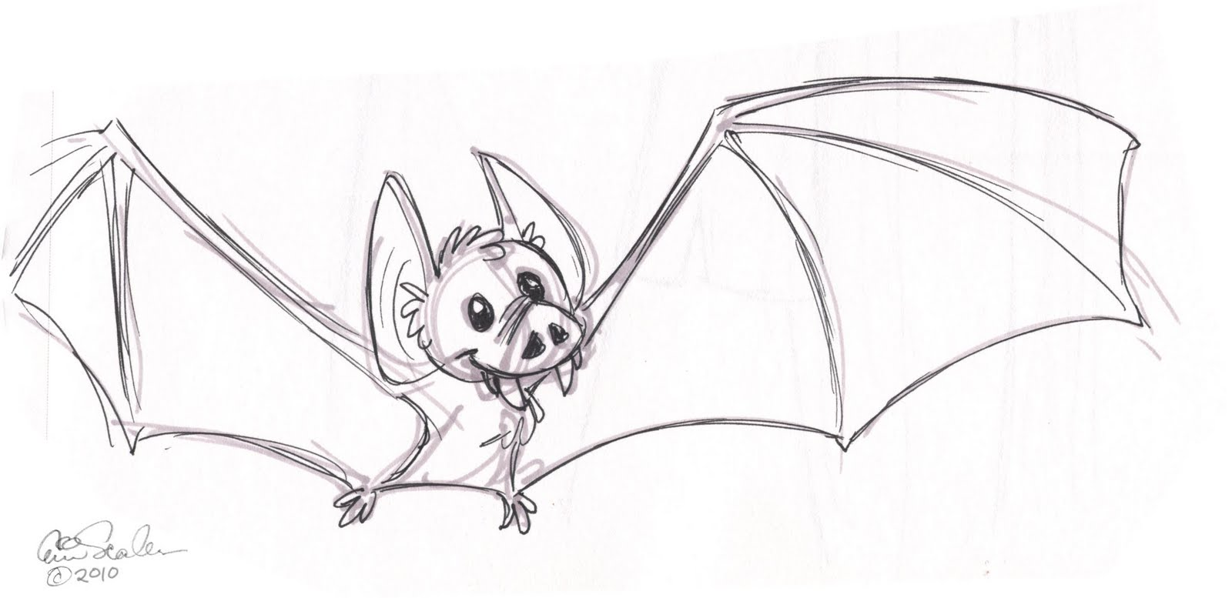](http://www.google.com.au/url?sa=i&rct=j&q=sketch%20of%20bat&source=images&cd=&cad=rja&docid=CCf0_mQNyrVTYM&tbnid=7CxequJsepgrcM:&ved=0CAUQjRw&url=http://ericscalessketchbook.blogspot.com/2010_10_01_archive.html&ei=dBNBUeXkGMnslAWVm4CwCw&psig=AFQjCNHtZ6L4UE_TwT6YCnXboF0WlqIyug&ust=1363305677248765)

List 3 adaptations that this animal has that help it survive?

_____________________________________________________________________________________________________________________________________________________________________________________________________________ (3 marks)

1. Use the diagram below to answer the questions that follow.

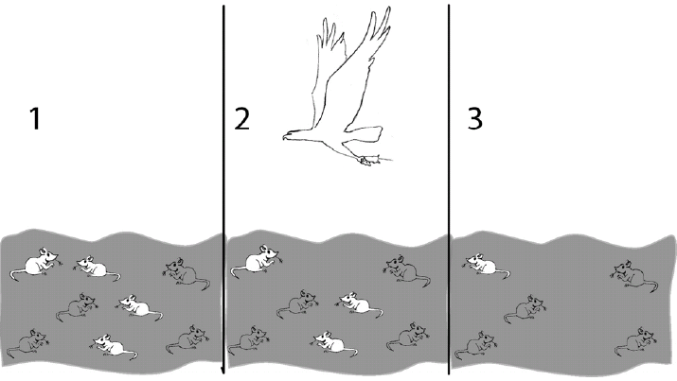

Time

1. In the diagram above which characteristic is being selected for?

_____________________________________________________________________________________________________________________

(1 mark)

1. How is this characteristic passed on to later generations of mice?

_________________________________________________________________________________________________________________________________________________________________________________

(1 mark)

1. How would the original difference seen in the characteristic have been produced?

______________________________________________________________________________________________________________________

(1 mark)

1. Mosquitoes resistant to the pesticide DDT first appeared in India in 1959. This resistance is thought to be due to natural selection. The table below shows how the mosquito resistance to DDT changed over time in India once spraying began.

|  |  |
| --- | --- |
| Time (months) | Mosquitoes resistant to DDT (%) |
| 0 | 4 |
| 4 | 30 |
| 8 | 45 |
| 12 | 75 |

(a) Graph this data. (5 marks)

|  |  |  |  |  |  |  |  |  |  |  |  |  |  |  |  |  |  |  |  |  |  |  |  |  |
| --- | --- | --- | --- | --- | --- | --- | --- | --- | --- | --- | --- | --- | --- | --- | --- | --- | --- | --- | --- | --- | --- | --- | --- | --- |
|  |  |  |  |  |  |  |  |  |  |  |  |  |  |  |  |  |  |  |  |  |  |  |  |  |
|  |  |  |  |  |  |  |  |  |  |  |  |  |  |  |  |  |  |  |  |  |  |  |  |  |
|  |  |  |  |  |  |  |  |  |  |  |  |  |  |  |  |  |  |  |  |  |  |  |  |  |
|  |  |  |  |  |  |  |  |  |  |  |  |  |  |  |  |  |  |  |  |  |  |  |  |  |
|  |  |  |  |  |  |  |  |  |  |  |  |  |  |  |  |  |  |  |  |  |  |  |  |  |
|  |  |  |  |  |  |  |  |  |  |  |  |  |  |  |  |  |  |  |  |  |  |  |  |  |
|  |  |  |  |  |  |  |  |  |  |  |  |  |  |  |  |  |  |  |  |  |  |  |  |  |
|  |  |  |  |  |  |  |  |  |  |  |  |  |  |  |  |  |  |  |  |  |  |  |  |  |
|  |  |  |  |  |  |  |  |  |  |  |  |  |  |  |  |  |  |  |  |  |  |  |  |  |
|  |  |  |  |  |  |  |  |  |  |  |  |  |  |  |  |  |  |  |  |  |  |  |  |  |
|  |  |  |  |  |  |  |  |  |  |  |  |  |  |  |  |  |  |  |  |  |  |  |  |  |
|  |  |  |  |  |  |  |  |  |  |  |  |  |  |  |  |  |  |  |  |  |  |  |  |  |
|  |  |  |  |  |  |  |  |  |  |  |  |  |  |  |  |  |  |  |  |  |  |  |  |  |
|  |  |  |  |  |  |  |  |  |  |  |  |  |  |  |  |  |  |  |  |  |  |  |  |  |
|  |  |  |  |  |  |  |  |  |  |  |  |  |  |  |  |  |  |  |  |  |  |  |  |  |
|  |  |  |  |  |  |  |  |  |  |  |  |  |  |  |  |  |  |  |  |  |  |  |  |  |
|  |  |  |  |  |  |  |  |  |  |  |  |  |  |  |  |  |  |  |  |  |  |  |  |  |
|  |  |  |  |  |  |  |  |  |  |  |  |  |  |  |  |  |  |  |  |  |  |  |  |  |

Spare graph

|  |  |  |  |  |  |  |  |  |  |  |  |  |  |  |  |  |  |  |  |  |  |  |  |  |
| --- | --- | --- | --- | --- | --- | --- | --- | --- | --- | --- | --- | --- | --- | --- | --- | --- | --- | --- | --- | --- | --- | --- | --- | --- |
|  |  |  |  |  |  |  |  |  |  |  |  |  |  |  |  |  |  |  |  |  |  |  |  |  |
|  |  |  |  |  |  |  |  |  |  |  |  |  |  |  |  |  |  |  |  |  |  |  |  |  |
|  |  |  |  |  |  |  |  |  |  |  |  |  |  |  |  |  |  |  |  |  |  |  |  |  |
|  |  |  |  |  |  |  |  |  |  |  |  |  |  |  |  |  |  |  |  |  |  |  |  |  |
|  |  |  |  |  |  |  |  |  |  |  |  |  |  |  |  |  |  |  |  |  |  |  |  |  |
|  |  |  |  |  |  |  |  |  |  |  |  |  |  |  |  |  |  |  |  |  |  |  |  |  |
|  |  |  |  |  |  |  |  |  |  |  |  |  |  |  |  |  |  |  |  |  |  |  |  |  |
|  |  |  |  |  |  |  |  |  |  |  |  |  |  |  |  |  |  |  |  |  |  |  |  |  |
|  |  |  |  |  |  |  |  |  |  |  |  |  |  |  |  |  |  |  |  |  |  |  |  |  |
|  |  |  |  |  |  |  |  |  |  |  |  |  |  |  |  |  |  |  |  |  |  |  |  |  |
|  |  |  |  |  |  |  |  |  |  |  |  |  |  |  |  |  |  |  |  |  |  |  |  |  |
|  |  |  |  |  |  |  |  |  |  |  |  |  |  |  |  |  |  |  |  |  |  |  |  |  |
|  |  |  |  |  |  |  |  |  |  |  |  |  |  |  |  |  |  |  |  |  |  |  |  |  |
|  |  |  |  |  |  |  |  |  |  |  |  |  |  |  |  |  |  |  |  |  |  |  |  |  |
|  |  |  |  |  |  |  |  |  |  |  |  |  |  |  |  |  |  |  |  |  |  |  |  |  |
|  |  |  |  |  |  |  |  |  |  |  |  |  |  |  |  |  |  |  |  |  |  |  |  |  |
|  |  |  |  |  |  |  |  |  |  |  |  |  |  |  |  |  |  |  |  |  |  |  |  |  |
|  |  |  |  |  |  |  |  |  |  |  |  |  |  |  |  |  |  |  |  |  |  |  |  |  |